**Lesson 7.**

**Refractometry.**

Refractometry (from the Latin refraktus - refracted and the Greek metreo - measure, measure) is a section of applied optics, a physico-chemical research method that considers methods for measuring the refractive index of light during the transition from one phase to another.

In relation to chemistry, refraction has a broader semantic meaning. Refraction is a measure of the electronic polarizability of atoms, molecules, ions. The polarization of electron clouds in molecules is clearly manifested in the infrared (IR) and ultraviolet (UV) absorption of substances, but to an even greater extent it is responsible for the phenomenon that is quantitatively characterized by molecular refraction.

When light as electromagnetic radiation passes through matter, even in the absence of direct absorption, it can interact with electron clouds of molecules or ions, causing their polarization. The interaction of the electromagnetic fields of the light beam and the electron field of the atom leads to a change in the polarization of the molecule and the speed of the light flux. As the polarizability of the medium increases, so does the refractive index, the value of which is related to molecular refraction. This phenomenon is used along with the method of dipole moments to study the structure and properties of inorganic, organic, and organoelement compounds.

Refractometry is one of the most common methods for identifying chemical compounds, quantitative and structural analysis, and determining the physicochemical parameters of substances. Fields of application of this method: in medicine for determining the amount of glucose in biological fluids and drugs in solutions for determining protein in urine, blood serum, urine density, analysis of cerebral and joint fluid, density of subretinal and other fluids of the eye; in pharmacy for drug analysis; in the food industry and technology.

Refractometry is a method based on the phenomenon of refraction, a change in the rectilinear propagation of light during the transition from one medium to another, called refraction.

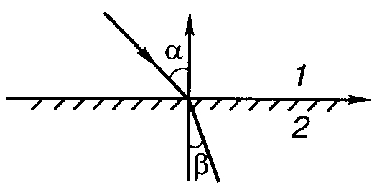

The refractive index (refractive index) is the ratio of the sine of the angle of incidence a of a beam of light to the sine of its angle of refraction b.



If a beam of light passes from or vacuum from air to another medium, then the angle of incidence is always greater than the angle of refraction. With an increase in the angle of incidence, the ratio between the fractions of light energy leaving for another medium and reflected from it changes.

Due to the fact that the refractive index depends on the wavelength, there are several refractive indices for the same substances, having the following designations:

n is the refractive index of the yellow sodium line (line D)

nC is the refractive index of the hydrogen red line (line C)

nF is the refractive index of the blue line of hydrogen (line F)

nG is the refractive index of the purple hydrogen line (line G)

The refractive index depends on the internal state of the substance, it also depends on the temperature, pressure, concentration, nature of the solvent. Therefore, to systematize the results obtained, the refractive index (accepted as standard), taken at a temperature of 20 ± 0.3 ° C, in the sodium spectrum (598.3 nm) is taken. The refractive index obtained under these conditions has the designation n20, which is used in reference 6 data on the basic physicochemical properties of substances. Typically, the measurement of the refractive index is carried out at a temperature of 20°C. However, when measuring at a different temperature, corrections for temperature are introduced according to the formula.

n \u003d n20 + (20 - t) 0.0002,

where n is the refractive index at the measured temperature;

n20 is the standard refractive index;

t is the temperature at which the measurement was carried out.

For water and aqueous solutions at temperatures of 20 ± 5 ° C, the refractive index changes by almost the same value, therefore, in this temperature range, for aqueous solutions, temperature correction is not necessary.

Abbe refractometers are the most common in analytical laboratories. The measurement accuracy on the Abbe refractometer reaches 0.0001–0.0003. The refractive index of the test substance in the Abbe refractometer is calculated directly on a scale or determined using special tables. In practice, refractometry is used to determine the concentration of solutions, if its value is not lower than 3%.

For most aqueous solutions that contain a single solute, the dependence of the refractive index on concentration is expressed by the following equation.



where n is the refractive index of the solution;

no is the refractive index of the solvent;

F is the refractive index factor, showing the magnitude of the increase in the refractive index with an increase in the concentration of the solution by 1%.

The F value can be found in the reference literature, or calculated experimentally on your own. For the most frequently performed determinations, there are tables and charts that allow you to quickly carry out the necessary calculations.

Refractometric determination is carried out on an Abbe refractometer at:

stable temperature (20.0±0.3°C),

Sodium D line spectrum (589.3 nm)

and in the range of refractive index from 1.3 to 1.7.

When working with a refractometer, the temperature can be adjusted by connecting the device to the plumbing system. As the temperature rises, the refractive index decreases, and as the temperature decreases, it rises accordingly.

In practice, refractometry is used to determine the concentration of solutions, if its value is not lower than 3%.

The device is calibrated with reference solutions or purified water (n_(〖20〗^° C)=1.333).

In control and analytical practice, the refractometry method is used to determine the authenticity and to quantify drugs.

The determination of the authenticity of medicinal substances is carried out on the basis of the establishment of the molar refractive index.

For the quantitative determination of substances by the refractometric method, the interval of a linear relationship between the concentration of solutions and the refractive index is determined.

Quantitative determination can be carried out by calculation or using a calibration curve.

Refractometers have a number of advantages:

measurement speed;

ease of maintenance;

minimal consumption of the test substance, which is especially important when working with expensive materials.

ABBE REFRACTOMETER is a visual optical instrument for measuring the refractive index of liquid and solid media. Its action is based on measuring the angle of total internal reflection in the case of an opaque medium under study or the limiting angle of refraction at a flat interface between transparent media (explored and known) when light propagates from a medium with a lower refractive index n1 to a medium with a higher refractive index n2.

The Abbe refractometer consists of two glass rectangular prisms - a measuring prism 3 with a high refractive index n2=1.7 (for the yellow sodium line λD=589 nm), with a polished hypotenuse face and an auxiliary folding prism 2 with a frosted hypotenuse face, a telescope, a reference scale, special compensator 6. In the field of view of the pipe, there is a sharp dividing line between light and dark fields, corresponding to the limiting angle.

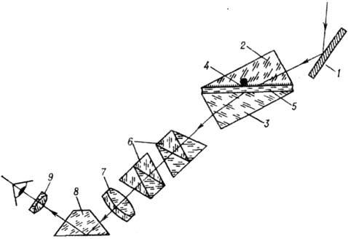

1 - lighting mirror; 2 - auxiliary folding prism; 3 - main measuring prism; 4 - matted face of the folding prism; 5 - test liquid; 6 - Amici prisms of the compensator; 7 - telescope lens; 8 - rotary prism; 9 - eyepiece of the telescope.

The test sample is placed on a measuring (refractometric) prism. It is made of a material with a known refractive index (most often a heavy flint) and has a refraction angle of 60°. At the input face of the measuring prism, light is refracted and total internal reflection is observed. The liquid analyzed sample does not flow down from the input face due to its horizontal arrangement. The prism is placed in a corrosion-resistant metal hollow chamber, which can be connected to an ultrathermostat. Before measurements, the chamber of the refractometer and the analyzed solution must have the same temperature. Above the measuring prism is a covering (illuminating) prism, placed in a frame, hinged. The window in the frame of the covering prism is designed to illuminate transparent substances examined in transmitted light. The refractometer can measure the refractive indices of translucent and dark-colored samples. For this, reflected light is used, which is obtained using a mirror hinged on the frame of a refractometric prism.

During the measurement, a beam of light rays is directed to the prism by a mirror or an illuminating window, refracted on the measuring plane of the prism and enters the refractometer body. Rays of light after passing through the guiding prism fall on the Amici prism system. The Amici prism consists of three glued prisms; light with a certain wavelength (usually the yellow sodium line, λ = 589.2 nm) passes through the Amici prism without deflection. By rotating the prisms, the coloration of the boundary line can be removed, this is done using the knurled head on the refractometer body. The head is marked with divisions indicating the level of dispersion. Then a beam of light rays falls on the lens and is focused in the upper window of the eyepiece field of view - the boundary line should be in the center of the upper field, while the scale of the refractive index and the percentage of sugar is visible in the lower part of the eyepiece field of view; The risk on the scale shows the measured value. Moving the boundary line and the refractive index scale in the field of view of the eyepiece is carried out using the head on the refractometer body. The eyepiece moves within 5 diopters.

The refractometer has two measuring scales, the upper one is used to measure the refractive index of substances in the range from 1.3 to 1.7. The accuracy of the device within n from 1.30 to 1.42 is 0.0004; with n from 1.42 to 1.7 - 0.0002.

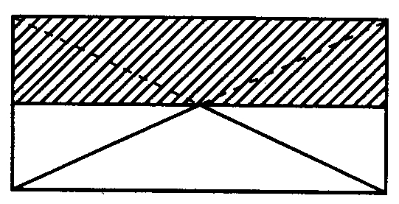

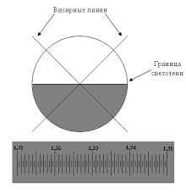

Analysis of mixtures consisting of 2 ingredients (multicomponent).

The analysis is based on a combination of refractometry with titrimetric methods of analysis. This option involves preparing a solution of the analyzed powder in mass-volume concentration, determining the refractive index of the resulting solution and the solvent used. Then, one or more components (depending on the composition) are determined by some titrimetric method, giving preference to the simplest one, which allows them to be determined in the presence of other ingredients without separation.

The content of this ingredient (C2) is calculated by the formula:



*в процентах (%) в граммах (г)*

Where,

C1 is the concentration of the first component (%) found by titrimetric methods;

F1, F2, - factors of refractive indices of solutions of substances determined by titrimetric methods;

n is the refractive index of the analyte;

no is the refractive index of the solvent;

P is the mass of the dosage form

For dry dosage forms:



Where:

F1C1 - factor and concentration of the substance determined by the chemical method;

F2 is the factor of the determined ingredient;

a is the mass of the weighed portion of the medicinal substance taken for analysis in grams;

P is the mass (volume) of the dosage form;

V is the volume of solvent taken to dissolve the sample.

Determination of the concentration of ethyl alcohol in water-alcohol solutions, tinctures.

The determination is carried out according to the refractive index and density of the tinctures. The refractive index of tinctures is equal to the refractive index of water and extractives.

The concentration of ethyl alcohol in percent in tinctures is determined according to the formula:



Where,

963 and 353 are empirical indicators,

n is the refractive index of the tincture,

n0 is the refractive index of water,

ρ is the density of the tincture,

ρ0 is the density of water.